GUJARAT TECHNOLOGICAL UNIVERSITY
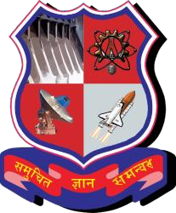

Chandkheda, Ahmedabad

Affiliated

G. H. Patel College of Engineering and Technology, Vallabh Vidyanagar

A
Project Report
On

WALK-THROUGH FACE RECOGNIZER

Under subject of
DESIGN ENGINEERING – I B
B. E. II, Semester – IV
Computer Engineering

Submitted by:
Group: 5
Sr. Name of student Enrollment no.
- Shardul Dave 130110107003
- Jeel Shah 130110107046
- Hemant Suthar 130110107058
4. Shrinand Thakkar 130110107059
5. Virali Thakkar 130110107060

Prof. Rajesh K. Ahir
(Faculty Guide)

Dr. Maulika S. Patel
Head of the Department

Academic year (2014-2015)

Index:

1. Introduction………………………………………………………..2

2. AEIOU Canvas…………………………………………………….3
2.1 Activity Canvas…………………………............................3
2.2 Environment Canvas……………………............................5
2.3 Interaction Canvas……………………...............................6
2.4 Object Canvas……………………………………………..7
2.5 Users Canvas……………………………………………...9

3. Empathy Canvas………………………………………………….10
4. Ideation Canvas…………………………………………………..12
5. Product Canvas…………………………………………………...14
6. Learning need matrix……………………………………………..16
7. Prototype model ………………………………………………….18
8. Scope In Future…………………………………………………...20

INTRODUCTION

Person identification is one of the most crucial building blocks for smart interactions. Amongst the person identification methods, face recognition is identified to be the most natural ones, as the face modality is modality that uses to identify people in day by day lives. Although other methods, such as fingerprint identification, can provide enhanced performance, those are not appropriate for natural smart interactions due to their intrusive nature. In comparison, face recognition provides passive identification that is the person to be identified does not need to cooperate or take any specific action.
Attendance record plays a important role in the academic achievement of institute students. Attendances of every students are being maintained by every school, college and university. Attendance Management Falls into two categories Namely: Conventional and Automated Methods.
The manual attendance record system is not efficient and requires more time to arrange record and to calculate the average attendance of each student. Moreover, it is very difficult to verify one by one student in a large classroom environment with distributed branches whether the authenticated students are actually responding or not. Hence there is a requisite of a system that will solve the problem of student record arrangement and student average attendance calculation.

Basically this is aimed for implementing a system that is capable of identifying the employees in an organization, students in institute marking their attendance.

Part 1 :- AEIOU canvas
AEIOU is an investigative tool to help interpret observations gathered by ethnographic practices in the field. It is an Observation tool. Its two primary functions are to code data, and to develop building blocks of models that will ultimately address the objectives and issues of a client.

Stage 1 :- Activities canvas

Activities are goal-directed sets of actions—paths towards things people want to accomplish.

General impressions/observations:
- Mapping attendance at institutions
- Radio Frequency Identification(RFID) at malls or tolls
- Recognizing face at MNC’s
- Detecting metals at monuments
- Acts as a counter at ports or tolls

Elements, Features and Special Notes:
- Mapping attendance for students and teachers
- Direct RFID- Account linking at tolls for tax(money) deduction
- Recognizing face for attendance mapping

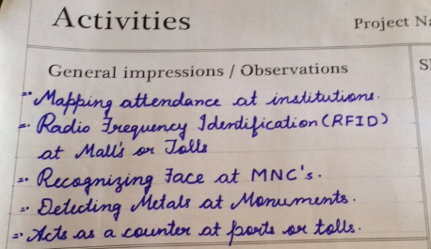
Elements, features and special notes
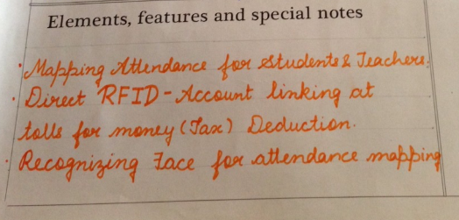
Sketch/photo-Summary of activities
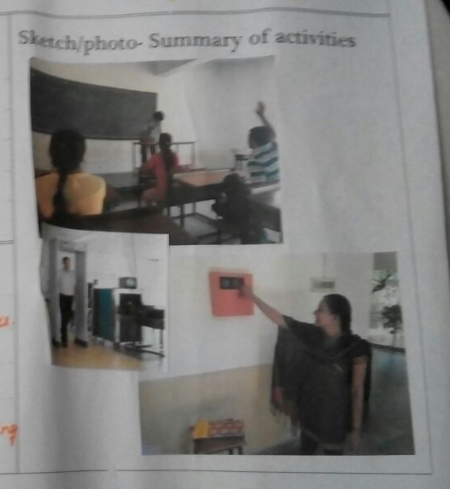

Stage 2:-Environment canvas

Environment includes the entire arena where activities take place.

General impressions/observations:
- Direct RFID-Account linking at tolls
- Mapping attendance for students
- Detecting metals at monuments
- Counting people at ports
Elements, Features and Special Notes:
- Mapping attendance at educational institutions
- Acts as a counter at public places
- Recognizing face for security purpose

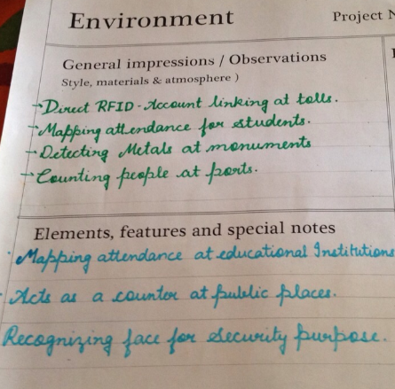

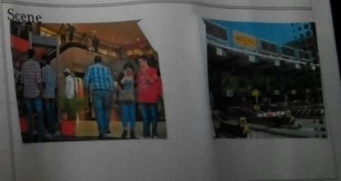

Stage 3:- Interactions canvas

Interactions are between a person and someone or something else; they are the building blocks of activities.

Our team interacted with

- PRIYANG BHATT: he suggested RFID as an option for attendance mapping and for security purpose

- FORAM JOSHI: talked about the flaws of biometric at institute

- RAJESH AHIR: he suggested some modifications in the current attendance mapping system at institute for teachers

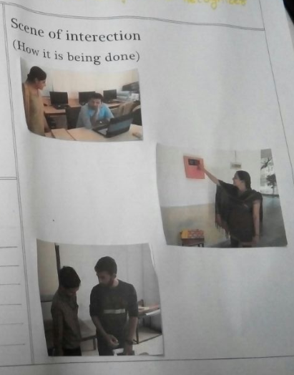
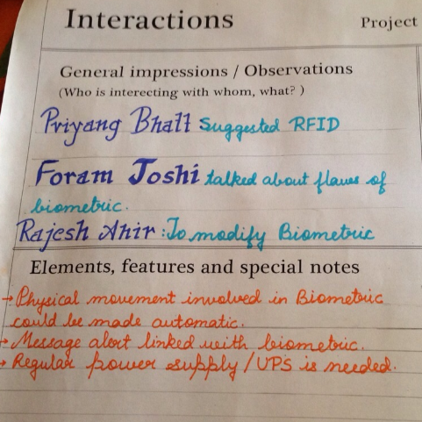

Stage 4:- Objects

Objects are building blocks of the environment, key elements sometimes put to complex or unintended uses (thus changing their function, meaning and context). The objects and devices people have in their environments and how do they relate to activities.

General impressions/observations (what component are involved)
  - Face recognizer
  - Metal detector
  - Attendance registers
  - Camera
  - Sensors
  - Biometric
  - RFID
Elements and features (How objects are relating to activities?)
- Recognizing face
- Detecting metal
- Attendance mapping
- Object sensing
- Bio sensing

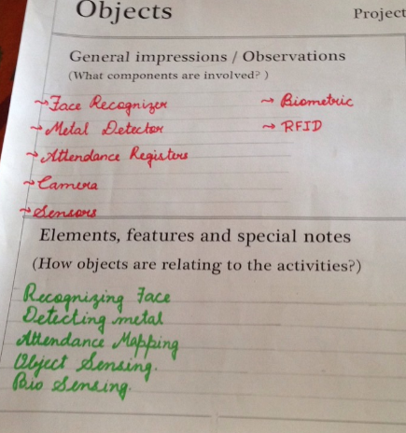

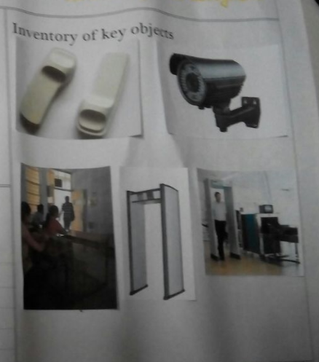

Stage 5 :- User canvas

Users are the people whose behaviors, preferences, and needs are being observed, their roles and relationships, their values and prejudices are being judged and kept in mind while designing anything new.

General impressions of People (who is present? Roles and Responsibility?
- Design engineers: keep on designing new inventions
- Maintenance staff: putting their efforts to keep the whole mechanism not only in working conditions but to work in efficient manner etc..
- Controller staff
- Manufactures
- Students
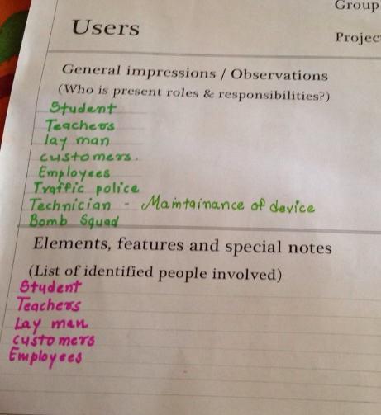
EMPATHY MAPPING CANVAS

Design for:
Face recognition
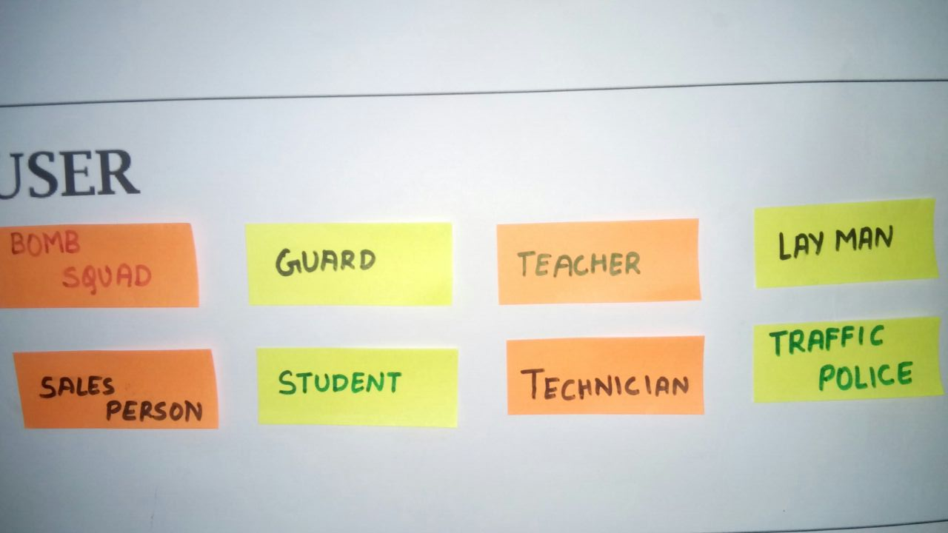
Users:
- Teacher
- Students
- Guard
- Technician
- Sales person
- Traffic police
- Lay man
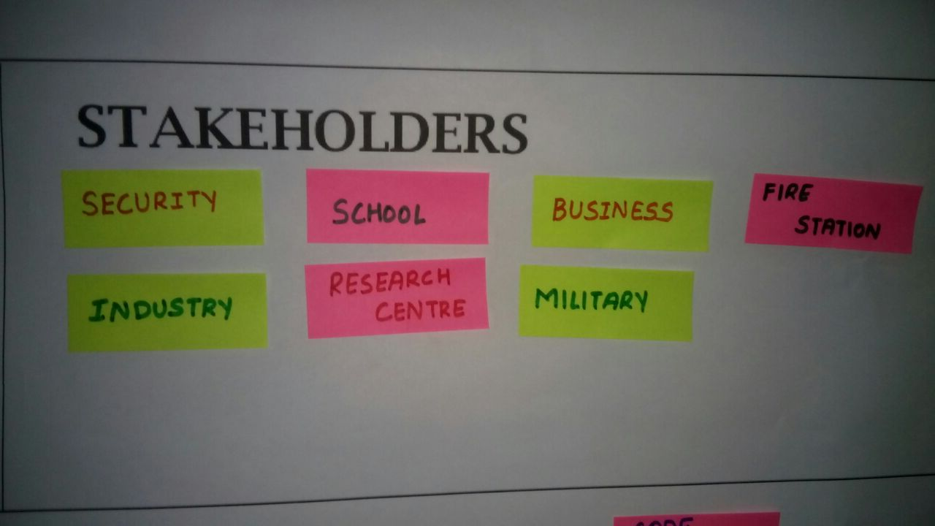
Stakeholders:
- School
- Business
- Military
- Industry
- police
- Security Guard

Activity:
- Bomb detection
- Garbage grabber
- Metal detection
- Code reading
- Attendance mapping
- Controlling traffic
- Counting

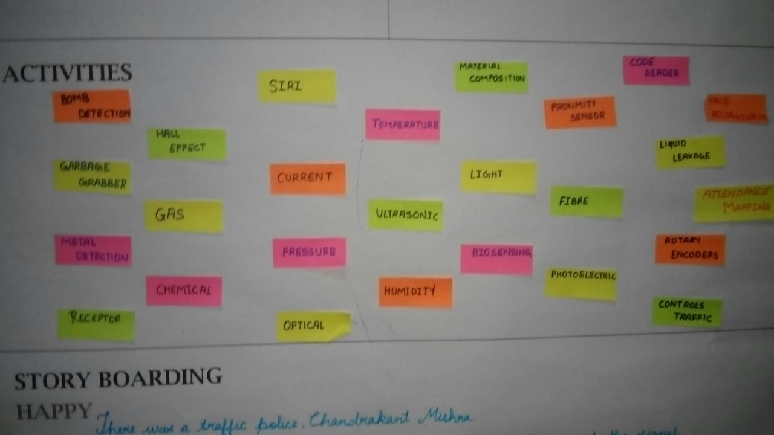

Story boarding:
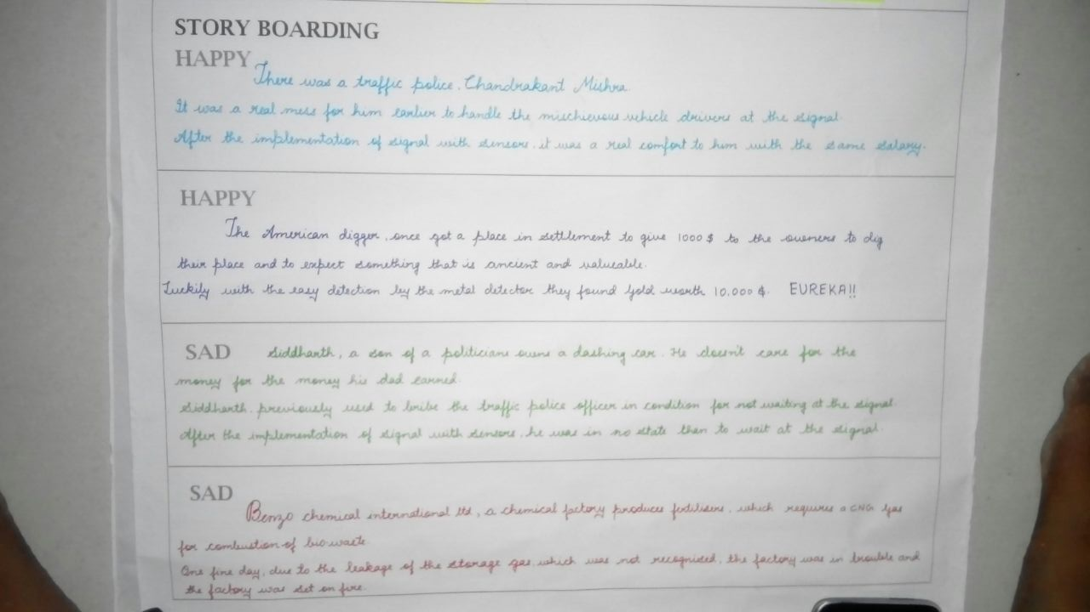

IDEATION MAPPING CANVAS

People:
- Teachers
- Students
- Doctors
- Army
- Employee
- Shopkeeper
- Bomb squad
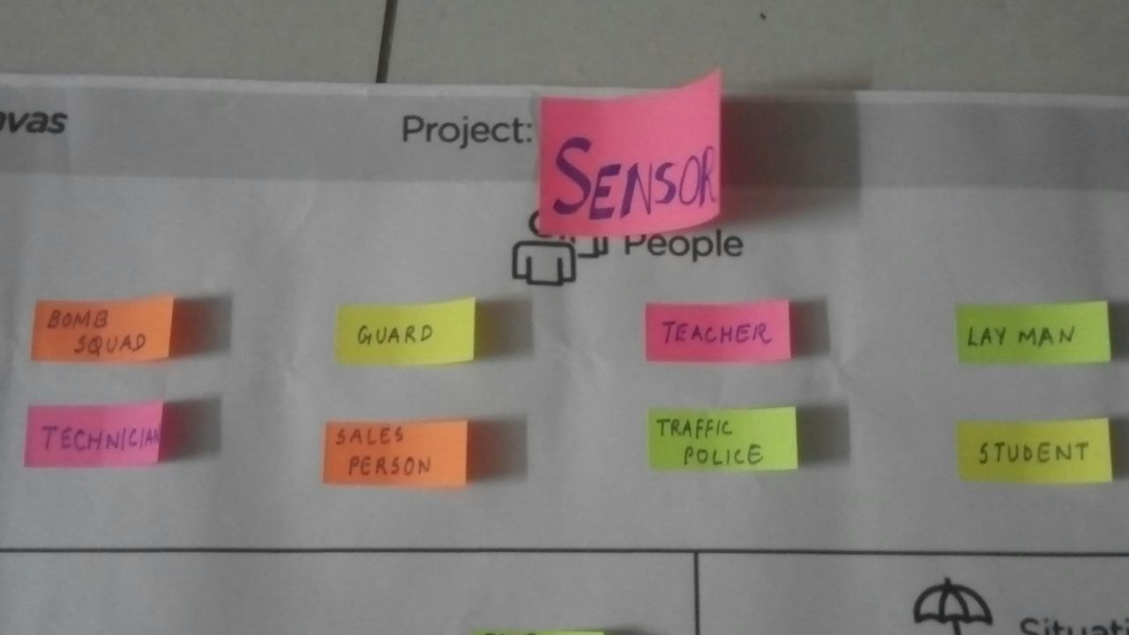
- Traffic police

Activity:
- Face recognition
- Object sensing
- Light sensing
- Distance mapping
- Barcode reader
- Ultrasonic wave sensing
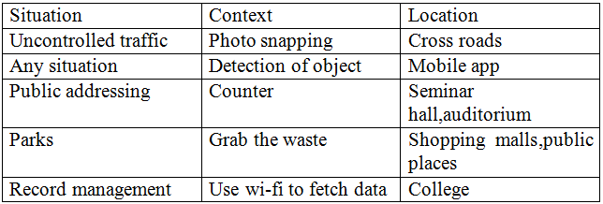
Situation/context/location:

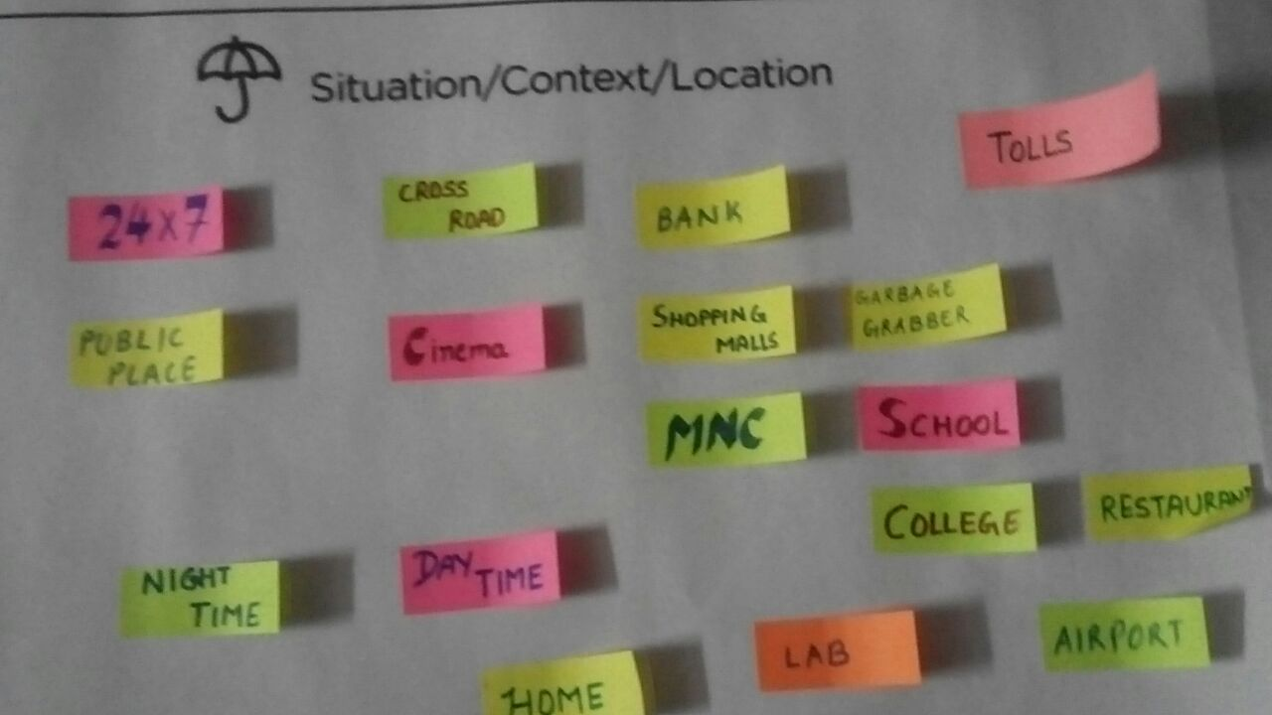

PRODUCT DEVELOPMENT CANVAS

Purpose:
- Attendance mapping
- Security
People:

- Teacher
- Student
- Bomb squad
- Security guard
- Traffic police
- Technician
- Sales person
- Lay man
Product feature:

- Easy tracking
- Security
- Loss prevention
- 24 X 7

Product function:

- Walk through face recognizer
- Counter

Components:

- Camera
- Sensor
- Computer
- Code reader
- Signal
- Students
PRODUCT DEVELOPMENT CANVAS

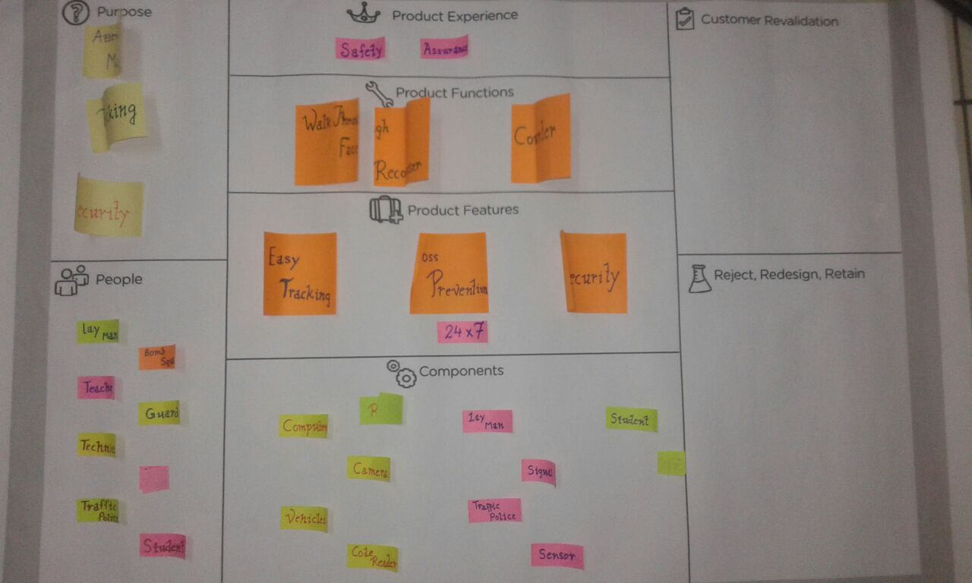

Part 2: Learning Needs Matrix
This part includes several processes, activities etc. distributed to be done in three years of BE, including this year. This part is divided further into following four components:
1. THEORIES/TOOLS/METHODS/APPLICATION PROCESSES INVOLVED: This component includes several algorithms like feature extraction, support vector machine (SVM), principle component analysis (PCA) etc.. and needs the understanding of skin, color, and shape based methods of face recognition.
2. APPLICABLE STANDARDS AND DESIGN SPECIFICATIONS/PRINCIPLES AND EXPERIMENTS: This part consists of various institutions, responsible for all standards and specifications of any software, algorithms. Examples include IEEE Standards, 6-sigma etc..
3 .SOFTWARE / SIMULATION/SKILL/ MATHEMATICAL REQUIREMENT: Various computational software and languages used are matlab , python, c-programming etc..
4. COMPONENTS MATERIALS’ AND STRENGTH CRITERIA: This part is responsible for the selection of suitable algorithm considering orientation criteria, effect of light etc. Algorithm which could be used should work well with different orientations, different light intensity, distance, etc. To check these we use several tests such as unit testing, module testing, system testing etc.
This sheet also helps students to understand and clarify their idea of what they want to do in successive upcoming semesters for their project.

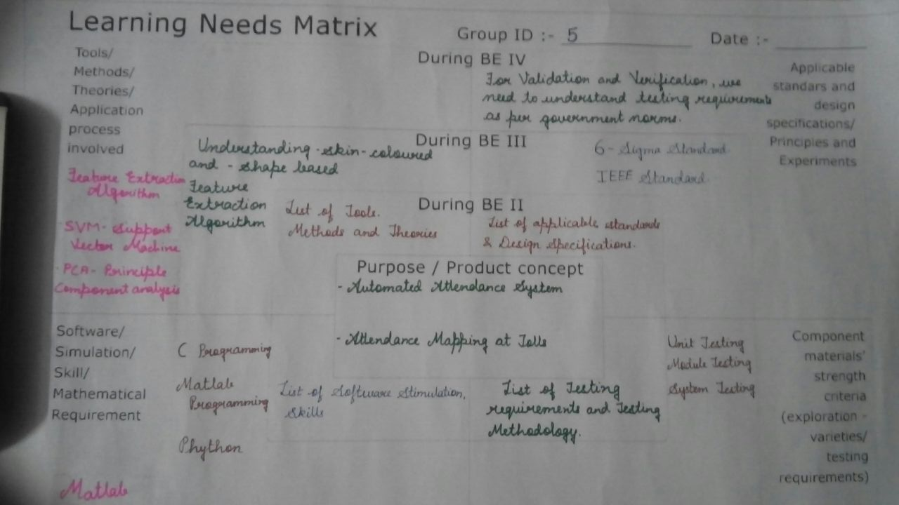

Fast-Prototype model / Conceptual Plan-Layout for process related branches
The followed screen shots are of prototype which is developed by us in Macromedia Flash 8.

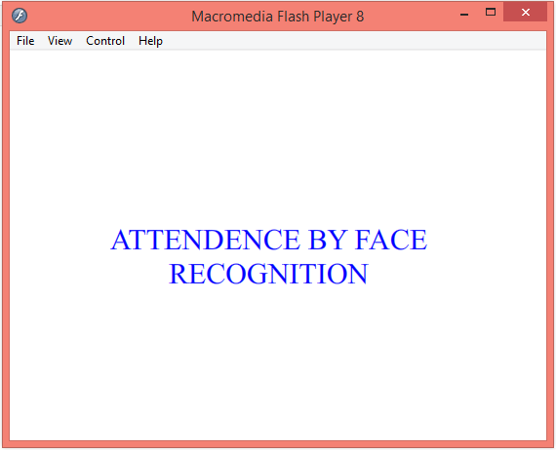

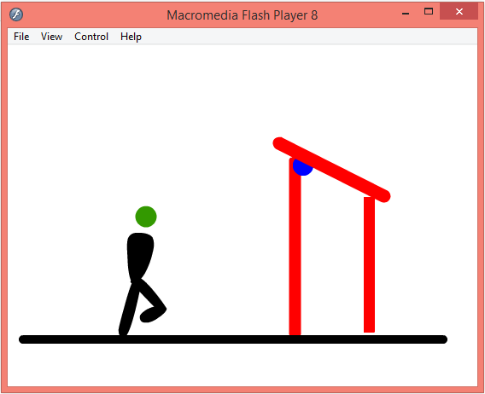
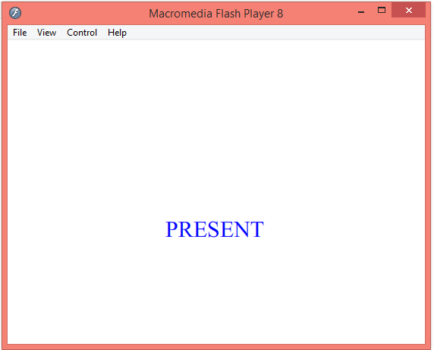
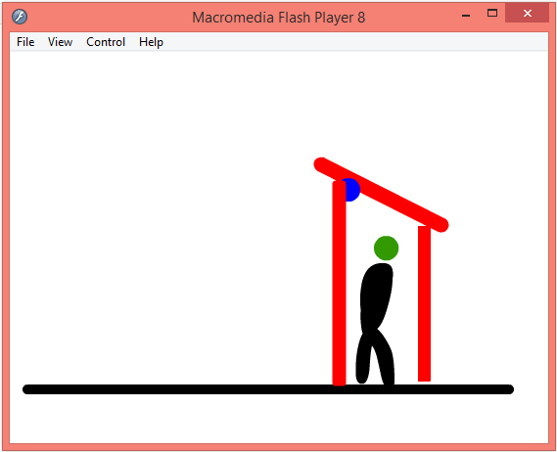

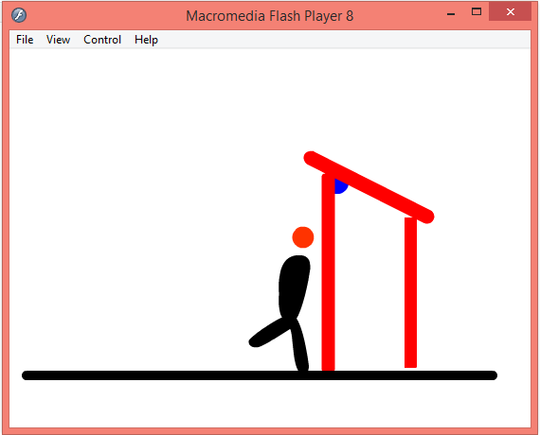

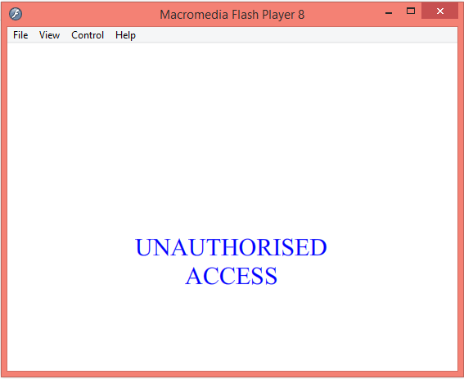

Scope In Future
Face recognition systems used today work very well under constrained conditions, although all systems work much better with frontal mug-shot images and constant lighting. All current face recognition algorithms fail under the vastly varying conditions under which humans need to and are able to identify other people. Next generation person recognition systems will need to recognize people in real-time and in much less constrained situations.
We believe that identification systems that are robust in natural environments, in the presence of noise and illumination changes, cannot rely on a single modality, so that fusion with other modalities is essential. Technology used in smart environments has to be unobtrusive and allow users to act freely. Wearable systems in particular require their sensing technology to be small, low powered and easily integrable with the user's clothing. Considering all the requirements, identification systems that use face recognition and speaker identification seem to us to have the most potential for wide-spread application.
Cameras and microphones today are very small, light-weight and have been successfully integrated with wearable systems. Audio and video based recognition systems have the critical advantage that they use the modalities humans use for recognition. Finally, researchers are beginning to demonstrate that unobtrusive audio-and-video based person identification systems can achieve high recognition rates without requiring the user to be in highly controlled environments.

